**DAILY ONLINE ACTIVITIES SUMMARY**

|  |  |  |  |  |  |  |  |
| --- | --- | --- | --- | --- | --- | --- | --- |
| **Date:** | **23/06/2020** | | | | **Name:** | **Syed Rabeya Aamir** | |
| **Sem & Sec** | **8th B** | | | | **USN:** | **4AL16CS112** | |
| Online Test Summary | | | | | | | |
| **Subject** | | **----** | | | | | |
| **Max. Marks** | | **---** | | **Score** | | **---** | |
| Certification Course Summary | | | | | | | |
| **Course** | **Exam Readiness: AWS Certified Solutions Architect – Associate (Digital).** | | | | | | |
| **Certificate Provider** | | | **Aws** | **Duration** | | | **2 hrs** |
| Coding Challenges | | | | | | | |
| **Problem Statement:**  **1)** Python program to find remainder when all array elements are multiplied. | | | | | | | |
| **Status: Solved** | | | | | | | |
| **Uploaded the report in Github** | | | | **YES** | | | |
| **If yes Repository name** | | | | **rabeya** | | | |
| **Uploaded the report in slack** | | | | **YES** | | | |

**Certification Course Details:**



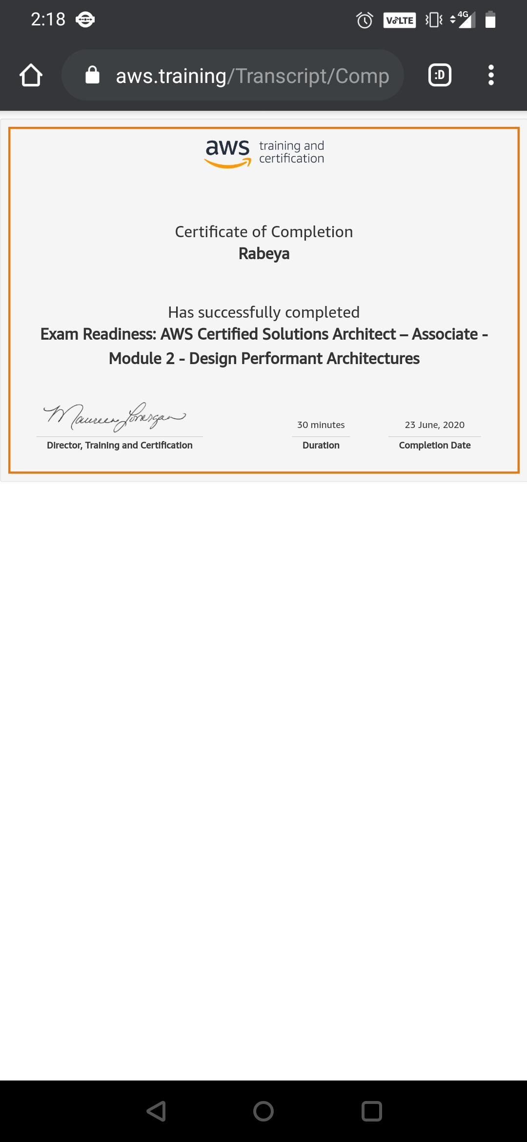

# CODE:

Program no:1

# Python program to find remainder when all array elements are multiplied.

def findremainder(arr, lens, n):

mul = 1

# find the individual

# remainder and

# multiple with mul.

for i in range(lens):

mul = (mul * (arr[i] % n)) % n

return mul % n

# Driven code

arr = [ 100, 10, 5, 25, 35, 14 ]

lens = len(arr)

n = 11

# print the remainder

# of after multiple

# all the numbers

print( findremainder(arr, lens, n))